**1. Affine Transformation** - Combination of linear transformation and translation of vectors. In affine transformation, a parallel line maps into parallel lines and finite points map into finite points. But origin does not necessarily map into origin. Affine transformation preserves ratios. Some common examples used in graphics are Translation, Rotation, and Scaling. Over 2D homogeneous coordinates can be put in 3d matrix.

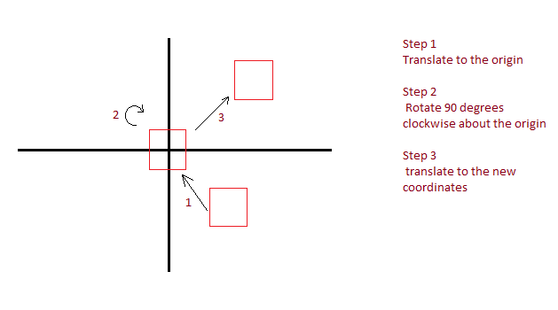

**2a.** Move/Translate the image to the origin by first getting the center of the image which is (7,-4) Then using the translation formula and shifting the coordinates left 7 and up 4 (a,b) = (-7,4)

$$\left[\begin{matrix}1 & 0 & -7 \\ 0 & 1 & 4 \\ 0 & 0 & 1\end{matrix}\right]$$ $\left[\begin{matrix}7 \\ -4 \\ 1\end{matrix}\right]$* = $\left[\begin{matrix}7+0-7 \\ 0-4+4 \\ 0+0+1\end{matrix}\right]$ = $\left[\begin{matrix}0 \\ 0 \\ 1\end{matrix}\right]$

Now rotate this image clockwise 90 degree **about the origin** which should produce the same result (0,0).

$\left[\begin{matrix}cos⁡(-90) & -sin⁡(-90) & 0 \\ sin⁡(-90) & cos⁡(90) & 0 \\ 0 & 0 & 1\end{matrix}\right]$ = $\left[\begin{matrix}0 & 1 & 0 \\ -1 & 0 & 0 \\ 0 & 0 & 1\end{matrix}\right]$ $\left[\begin{matrix}7 \\ -4 \\ 1\end{matrix}\right]$* = $\left[\begin{matrix}0 \\ 0 \\ 1\end{matrix}\right]$

We can test this by checking one of the corners for example, the top left (-1,1), should rotate 90 degrees clockwise and equal (1,1).

$\left[\begin{matrix}0 & 1 & 0 \\ -1 & 0 & 0 \\ 0 & 0 & 1\end{matrix}\right]$ $\left[\begin{matrix}-1 \\ 1 \\ 1\end{matrix}\right] =\left[\begin{matrix}0+1+0 \\ 1+0+0 \\ 0+0+1\end{matrix}\right]$* = $\left[\begin{matrix}1 \\ 1 \\ 1\end{matrix}\right]$ = (1,1)

We now translate the image to the last destination. The origin of the current location is (0,0) and I am moving it to the origin of the new location which is (4,2) = (a,b)

$\left[\begin{matrix}1 & 0 & 4 \\ 0 & 1 & 2 \\ 0 & 0 & 1\end{matrix}\right]$ $\left[\begin{matrix}0 \\ 0 \\ 1\end{matrix}\right]$* = $\left[\begin{matrix}0+0+4 \\ 0+0+2 \\ 0+0+1\end{matrix}\right]$ = $\left[\begin{matrix}4 \\ 2 \\ 1\end{matrix}\right]$ = (4,2)

**2b.** Reading from right to left – Translation * Rotation * Translation * Original Image origin

$\left[\begin{matrix}1 & 0 & 4 \\ 0 & 1 & 2 \\ 0 & 0 & 1\end{matrix}\right]$ $\left[\begin{matrix}0 & 1 & 0 \\ -1 & 0 & 0 \\ 0 & 0 & 1\end{matrix}\right]*\left[\begin{matrix}1 & 0 & -7 \\ 0 & 1 & 4 \\ 0 & 0 & 1\end{matrix}\right]*\left[\begin{matrix}7 \\ -4 \\ 1\end{matrix}\right]=$

$\left[\begin{matrix}1 & 0 & 4 \\ 0 & 1 & 2 \\ 0 & 0 & 1\end{matrix}\right]$ $\left[\begin{matrix}0 & 1 & 4 \\ -1 & 0 & 7 \\ 0 & 0 & 1\end{matrix}\right]*\left[\begin{matrix}7 \\ -4 \\ 1\end{matrix}\right]=$

*

*

Combo Matrix $\left[\begin{matrix}0 & 1 & 8 \\ -1 & 0 & 9 \\ 0 & 0 & 1\end{matrix}\right]$ $*\left[\begin{matrix}7 \\ -4 \\ 1\end{matrix}\right]=$

$\left[\begin{matrix}0-4+8 \\ -7+0+9 \\ 0+0+1\end{matrix}\right]=\left[\begin{matrix}4 \\ 2 \\ 1\end{matrix}\right]$